**Why do we make changes to your prescribed medicines?**

Hounslow Clinical Commissioning Group (HCCG) is responsible for managing the drugs budget spent by doctors in Hounslow borough. During 2011 more than 30 million pounds was spent in Hounslow on nearly 3.5 million prescription items.

NHS Hounslow and HCCG may advise changes to your medicines for many reasons, including:

* new safety concerns
* new evidence about the benefits of a drug
* new treatment guidelines

It is also important that we make the best use of the money we spend on medicines, without reducing the quality of the treatment patients receive.

If more money is spent on medicines than is available, the extra money has to come from other areas of healthcare. This means that we may not be able to provide all the services we would like.

HCCG and NHS Hounslow continually check the cost of the medicines to see if savings can be made. Support is given to practices to make such changes to patients’ medication when necessary.

**What sort of changes do we make?**

The changes we make can be split into different categories:

***Generic Switches***

The generic name of a medicine is the actual name of the active ingredient, rather than the trade name, which is chosen by the manufacturer. For example, Panadol is just one brand name for the medicine paracetamol.

The generic medicine is manufactured to the same tight quality controls and contains the same active ingredients, although the appearance may be slightly different. Competition between different manufacturer’s means that medicines prescribed by the generic name usually cost much less.

***Brand Switches***

Occasionally it may be cheaper to prescribe a specific brand medicine rather than using the generic name.

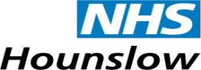 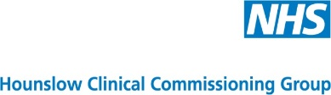

***Class (same group of medicines) Switches***

Some medicines may be grouped together in the same class depending on how they act in the body. There may be several different medicines in the same group. When there is no difference in how effective the different medicines are, the most cost effective one in the group will be given, where appropriate.

***Dose Changes***

Sometimes a low strength of a medicine is prescribed twice a day. It is often just as effective, more convenient and less expensive to prescribe a higher strength once daily.

***Tablets and Capsules***

Sometimes the same medicine may be available as both tablets and capsules. If there is a difference in cost, we will recommend that the less expensive one is prescribed, if appropriate.

**Points to remember**

* Money wasted means less is available for other NHS services
* Making changes to your medicines does not mean that you are receiving a reduced quality service
* If you have a leaflet or a letter which gives information about the changes to your medicines, read it carefully and keep it for your records
* Always follow the directions printed on the label of your medicines or take them as directed

September 2012

**Further Information**

As with all medication, there is a possibility you may experience side effects. Usually these are mild and get better with time.

For more information, always read the leaflet that comes with your medication and discuss any concerns with your local pharmacist (chemist) or doctor.

Local pharmacies offer free NHS services that help you get the greatest possible benefit from your prescribed medicines. If you have been prescribed a new or different medicine for certain long term illnesses (such as asthma, diabetes or high blood pressure), or if you want to know more about your regular prescription medicines, your pharmacist will be happy to advise you or arrange a review meeting.

PRACTICE OR PHARMACY STAMP

**Getting value out of the medicines you need**

Acknowledgment to NHS Derbyshire County

 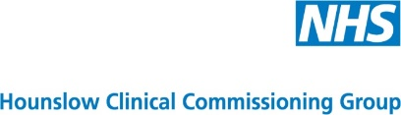

**Medication Changes**

**A Guide for Patients**

**Chan**